## **TOPS TECHNOLOGIES**

Trainig | Outsourcing | Placement | Study Abroad

## **Software Engineering Assignment**

### **Module-1**

# **1)What is software? What is software engineering**?

* **S/W is the language of computer programs and related data that provide the instructions for telling a computer what to do and how to do it**

# **2)Explain types of software**

* (**i)System software/operating system:provide the basic funtions for computer usage and helps to run the computer hardware and system.**
* **Basically OS coordinates the different for hardware components of a computer**
* **Ex. Linux,windows,ios**

**(ii)Application s/w:is the general designation of computer programs for performing user tasks.**

**-Types of application s/w**

**1)Mobile app**

**-Application that run on mobile**

**-Ex. Ig,fb,etc…**

**2)Deskstop app**

**-That run stand-alone in a deskstop or laptop computer.**

**-Ex. Ms office suite which includes Word,Excel,Power point.**

**-Ex. Outlook for email,Chrome,Mozila are web browser.**

**3)Web app:**

**-That run on a web browser**

**-ex google.com,facebook.com,etc..**

* **(iii)Programming s/w:**

**-is the process of designing,writing,testing and maintaining the source code of computer program**

**-This s/w is pawritten in a programming language.**

**-This purpose of programming is to create a program that exhibits a certain desired behavior.**

**-ex.c++,html,java,php, python and visual basic.**

# **3)What is SDLC? Explain each phase of SDLC**

* **Timeline+budget+quality**
* **A step by step approach to devlop any products/software high quality,lowest cost with shortest possible time.**
* **Phases:(i)Planning/Requirement Gathering(what):Establish Customer Needs**
* **(ii)Analysis(How):Model and Specify the requirements- -What ||**
* **(iii)Designing (DFD, Flow chart,ER,Use case):Model And Specify a Solution- -Why ||**
* **(iv)Implementation/Coding/Building:Construct a Solution In Software**
* **(v)Testing(QA):Validate the Solution In Software**
* **(vi)Maintenance:Repair defects and adapt the solution to the new requirements**

# **4)What is DFD?Create a DFD diagram on Flipkart**

* **A Data Flow Diagram is a traditional way to visualized the information flows within a system. A neat and clear DFD can depict a good amount of the system requirements graphically. It can be manual, automated,or a combination of both.**
* **It shows how information enters and leaves the system, what changes the information and where information is stored. The purpose of a DFD is to show the scope and boundaries of a system as a whole. It may be used as a communications tool between a systems analyst and any person who plays a part in the system that acts as the starting point for redesigning a system.**
* **0 level DFD diagram:**

## 

**Level 1 DFD diagram:**

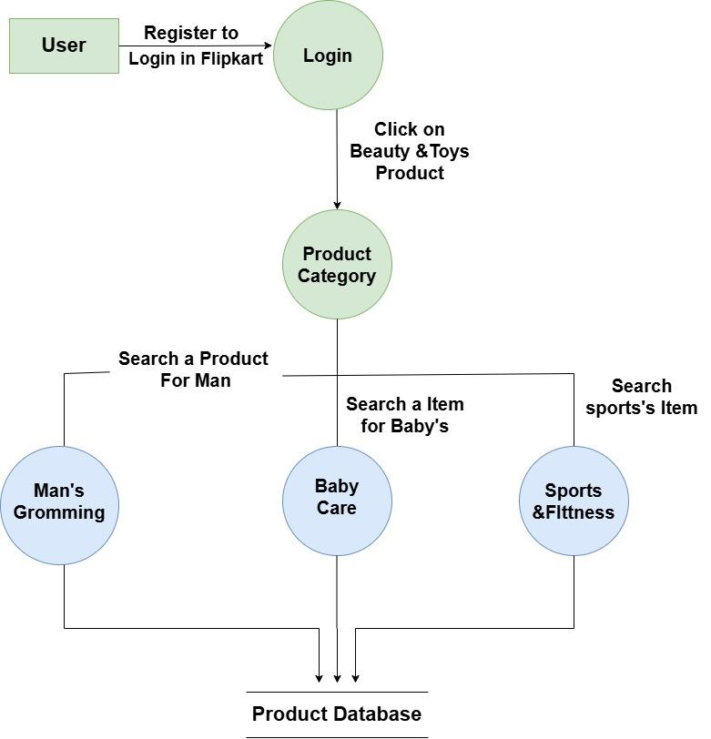

* **Level 2 DFD diagram:**

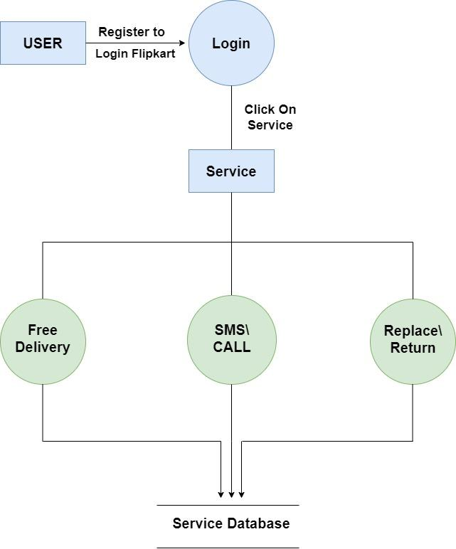

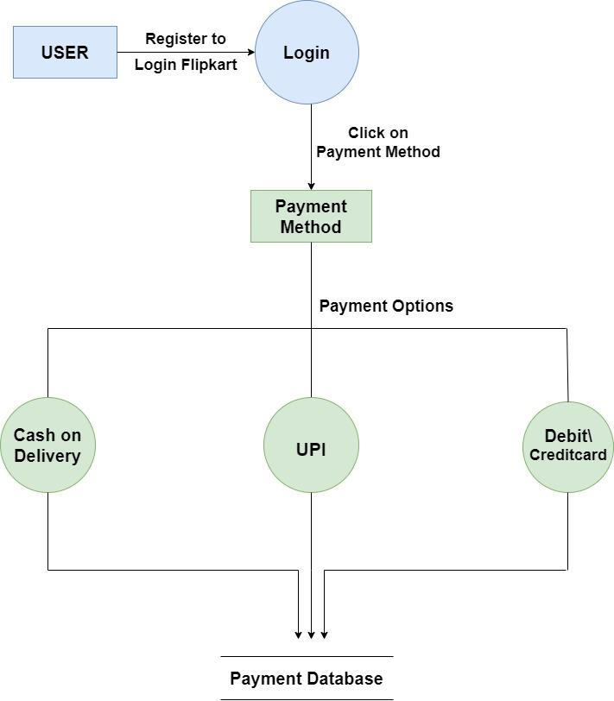

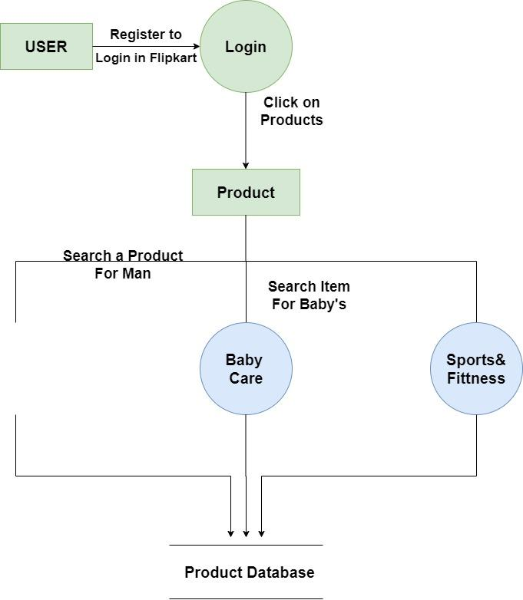

# **5.) What is Flow Chart? Create a flowchart to make addition of two numbers**

* **A flowchart is a graphical representation of the operations involved in a data processing system.**

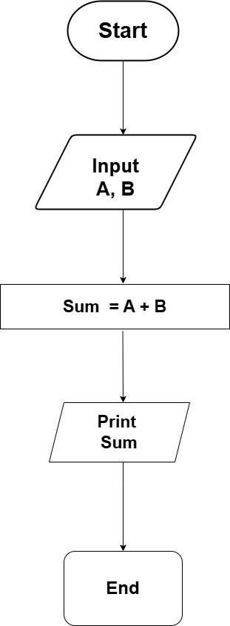

# **6.) What is Use case Diagram? Create a use-case on bill payment on paytm.**

* **There are lots of use-case for robotic hardware, from helping disabled users to automating factories.**

